CSS Statements

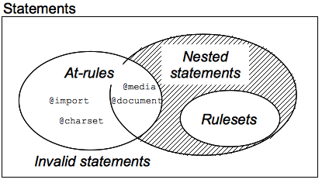

The main building blocks of style sheets is called **Rulesets.** A Building block with a non-space characters which it ends at the first closing brace is called a **statement.** Statements consists of two kinds, they are:

1. Rulesets also known as rules that consists of a declaration block and a selector.
2. At-rules in which it starts with an @ sign at the beginning followed by an identifier until the end of the statement.

**Rulesets**

A CSS ruleset

Ex:

**div p, #id:first-line** : This is called a group of selectors

**{**

**content**  : This is an example of CSS block in which the braces delimits the st **}** art and end of the block

**{**

**background-color : pink;** : This is an example of a declarations block

**background-style : none**

**}**

**At-Rule**

This is a statement provides CSS instructions to perform. A statement starts with @ sign following a keyword in which it acts as an identifier is the common syntax of the at-rule.

There are two types of at-rule, they are;

1. Regular Rules; and
2. Nested Rules

**Regular Rules**

This at-rules follows the regular syntax which is @[keyword](rule);

Ex:

1. @charset defines a character set which comes in handy that contains non-ASCII characters.
2. @import in which it is inserted at the top of the file for the style to include and external .css file.
3. @namespace is used for XHTML selectors in CSS.

**Nested Rules**

This contains a subset statements. The syntax is @[keyword] {/* Statements */}

Ex:

1. @document in which it applies to a specific page, some will be ignored on other pages
2. @font-face allows to load a custom-made font on a webpage, it also accepts statements that serve and create fonts.
3. @keyframes allows to mark the start and stop for animation
4. @media is used for targeting specific style in the screen.
5. @page contains a pseudo-element for styling :left, :first and :right margin of the page